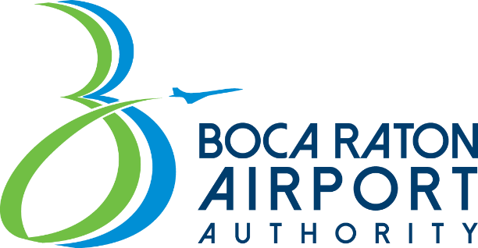
Board Meeting
Materials Notice
Boca Raton Airport Authority Board meeting agendas will be posted seven days prior to each meeting or workshop. Copies of meeting materials or individual agenda items may be requested via email to Airportauthority@bocaairport.com or by calling 561-391-2202 x205

