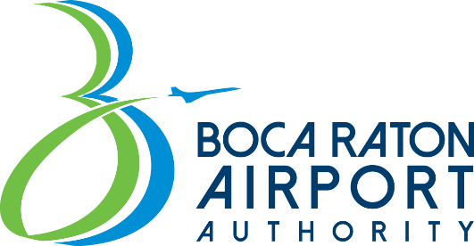

BOCA RATON AIRPORT AUTHORITY WORKSHOP July 9, 2024
1:00 P.M. – 3:00 P.M.

BOCA RATON AIRPORT ADMINISTRATION BUILDING 903 NW 35TH STREET
BOCA RATON, FL 33431

AGENDA

Roll Call

ROBERT TUCKER CHAIR
RANDY NOBLES VICE-CHAIR
CHERYL BUDD SECRETARY/TREASURER
MITCHELL FOGEL BOARD MEMBER
GENE FOLDEN BOARD MEMBER
JAMES R. NAU BOARD MEMBER
MELVIN POLLACK BOARD MEMBER

- Sustainability Management Plan.

- Leasing Policy.

- Public Comment.

- Next Steps.

